Little Free Pantry
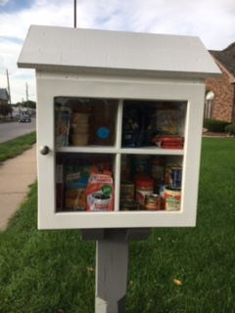
The Little Free Pantry is a solution to immediate and local need for the Bayliss West Neighborhood.
Whether a need for food or a need to give, the Little Free Pantry facilitates neighbors helping neighbors, building community.
Please note that if you are donating can foods – purchase those with the easy to remove lids.
Bags or boxes of cereal Shampoo body lotion Cake Mix
Wet wipes Pasta laundry soap Tuna fish
Soups bottled juice hamburger helper disposable razor
Crackers canned chicken peanuts Band aides
Jelly Pop Tarts bar soap pasta sauces
Salt sugar vegetable oil salad dressing
Granola bars popcorn deodorant Protein bars
Beef Ravioli individual packed fruits canned fruit Canned vegetables

*any individually wrapped items is acceptable.

Food Drive by: Bring your items on:

